1. Dynamic Memory Allocation for int type

Program :

#include<iostream>

using namespace std;

int main()

{

int \*p=new int;

\*p=5;

cout << \*p;

delete p;

return 0;

}

Output :

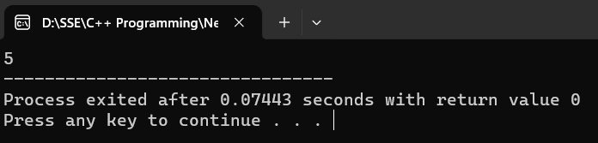

1. Dynamic Memory Allocation for float type

Program :

#include<iostream>

using namespace std;

int main()

{

float \*p=new float;

\*p=6.5;

cout << \*p;

delete p;

return 0;

}

Output :

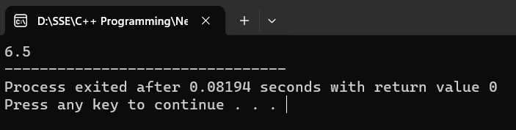

1. Dynamic Memory Allocation for char

Program :

#include<iostream>

using namespace std;

int main()

{

char \*p=new char;

\*p='A';

cout << \*p;

return 0;

}

Output :

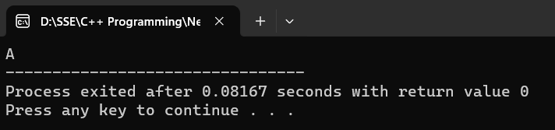

1. Dynamic Memory Allocation for string

Program :

#include<iostream>

using namespace std;

int main()

{

string \*p=new string;

\*p="Rajan";

cout << \*p;

return 0;

}

Output :

